**8-BIT DIVISION:**

**EXP NO:4**

**AIM:**To write an assembly language program to implement 8-bit addition using 8085  
processor.

**APPARATUS:** GNUSim8085

**ALGORITHM:**

1)Start the program by loading a register pair with the address of the memory location.  
2) Move the data to a register.  
3) Get the second data and load it into the accumulator.  
4) Subtract the two register contents.  
5) Increment the value of the carry.  
6) Check whether the repeated subtraction is over.  
7) Store the value of the quotient and the remainder in the memory location.  
8) Halt.   
**PROGRAM:**

LDA 8501  
 MOV B, A  
 LDA 8500  
 MVI C,00  
LOOP:   CMP B

JC LOOP1

SUB B

 INR C  
JMP LOOP    
LOOP1:  STA 8502  
MOV A, C  
STA 8503  
 RST 1

**INPUT:**

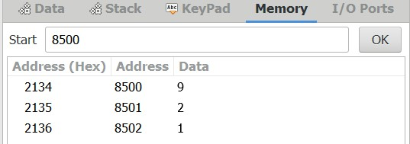

**OUTPUT:**

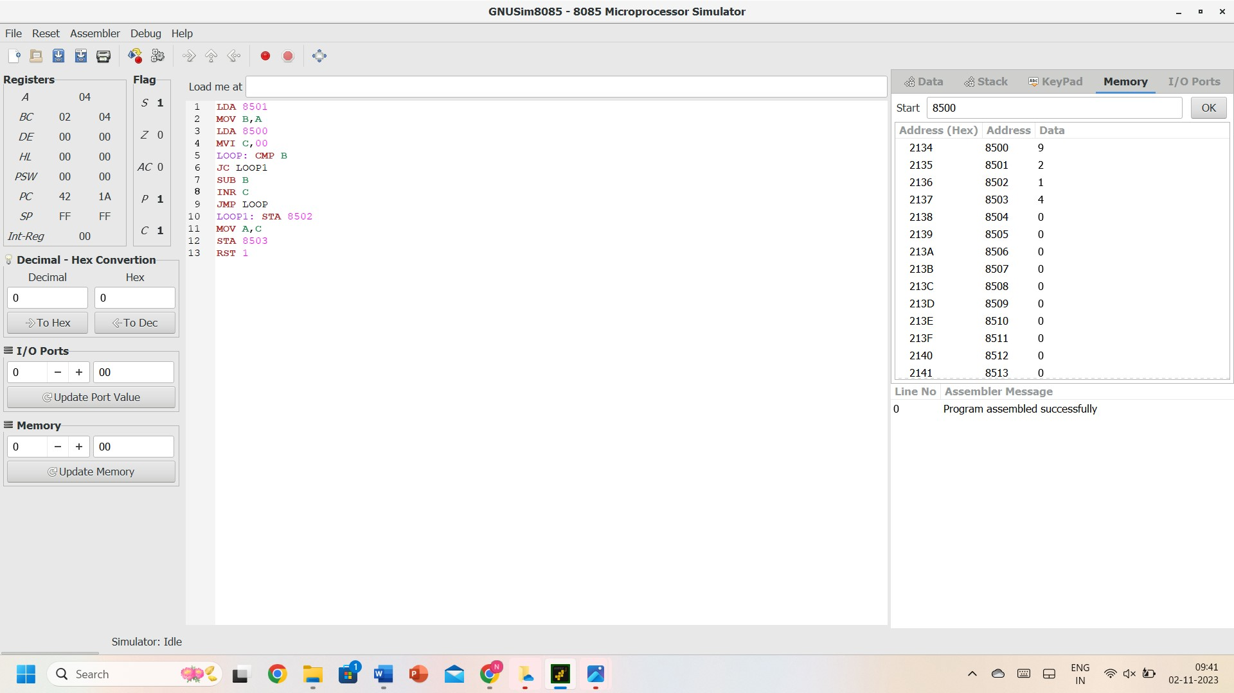

**RESULT:** Thus, the program was executed successfully using 8085 processor simulators.